**INTERNSHIP REPORT**

**On**

**Digital Phenotyping for Early Detection of Student Stress**

**By**

**Lokesh R M**

**Regd. No.: BU22CSEN0100145**

**IEEE CS Bangalore Chapter Internship and Mentorship Program – 2025**

**INTN3444 – Internship 2**

**(Duration: 01/04/2025 to 30/06/2025)**

**DEPARTMENT OF COMPUTER SCIENCE AND ENGINEERING**

**Gandhi Institute of Technology and Management**

**(DEEMED TO BE A UNIVERSITY)**

**BENGALURU, KARNATAKA, INDIA**

**SESSION:2022-2026**

**Acceptance / Offer Letter from Industry**

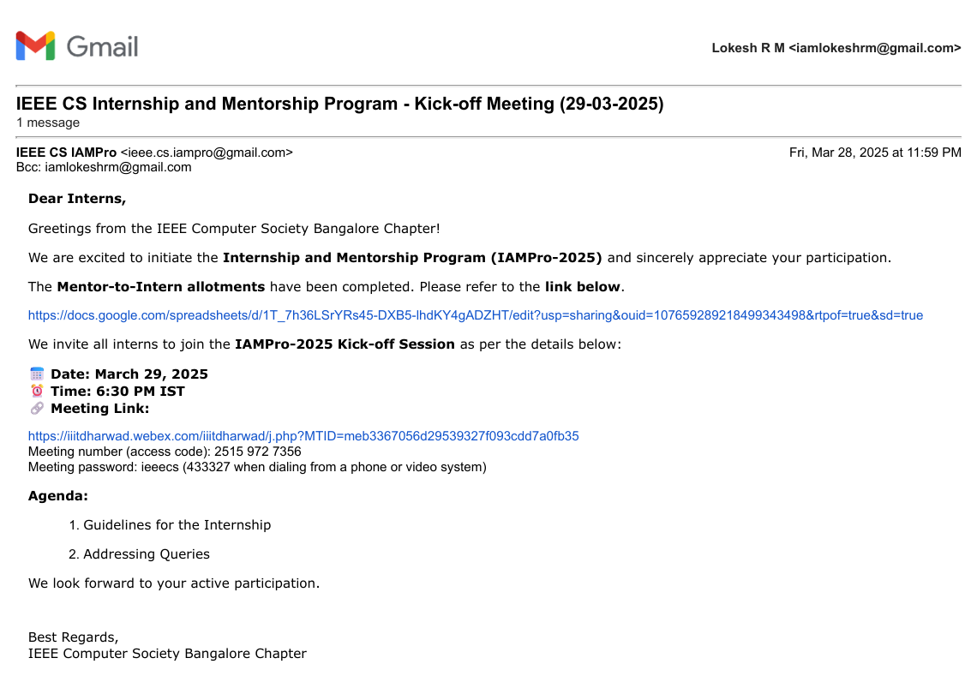

**Certificate Issued After Internship**

***(only for Students Completed from Industries)***

**CERTIFICATE**

This is to certify that the Internship entitled **“Digital Phenotyping for Early Detection of Student Stress (IEEE CS Bangalore Chapter Internship and Mentorship Program - 2025)”** is a bonafide record of work carried out by **Lokesh R M (BU22CSEN0100145)** submitted in partial fulfillment of requirement for the award of degree of **Bachelor of Technology in Computer Science and Engineering**.



Dr S Rakesh Kumar,

Assistant Professor,

Department of CSE,

GST, Bengaluru

**ACKNOWLEDGEMENT**

The satisfaction and euphoria that accompany the successful completion of any task would be incomplete without the mention of the people who made it possible, whose consistent guidance and encouragement crowned our efforts with success.

We consider it our privilege to express our gratitude to all those who guided us in the completion of the project.

We express our gratitude to Director Prof. **Basavaraj Gundappa Katageri** for having provided us with the golden opportunity to undertake this project work in their esteemed organization.

We sincerely thank **Dr. Y. Vamshidhar,** HOD, Department of Computer Science and Engineering, Gandhi Institute of Technology and Management, Bengaluru, for the immense support given to us.

We express our gratitude to our project guide, **Dr. S Rakesh Kumar, Assistant Professor**, Department of Computer Science and Engineering, Gandhi Institute of Technology and Management, Bengaluru, for their support, guidance, and suggestions throughout the project work.

Lokesh R M

BU22CSEN0100145

**Contents**

ABSTRACT vii

1. INTRODUCTION 1

2. LITERATURE REVIEW 3

3. EXISTING SYSTEM 7

4. PROPOSED SYSTEM 11

5. SYSTEM DESIGN 14

6. PROJECT IMPLEMENTATION 16

7. TOOLS & TECHNOLOGIES USED 17

9. RESULTS 22

10. CONCLUSION 23

**Tables**

1 - Summary of Key Studies in Digital Phenotyping for Stress Detection……………………7

**Figures**

1 - Proposed App Structure…………………………………………………………………..14

2 - Data Flow Diagram……………………………………………………………………….16

3 – 7 App / Project Output…………………………………………………………………...20

8 – Database Structure………………………………………………………………………..20

# **ABSTRACT**

This project presents StressSense, a cross-platform digital phenotyping system developed to enable the early detection of student stress. Serving as both Development Lead and Architecture Lead, I was responsible for shaping the end-to-end system design, guiding technical decisions, and ensuring seamless integration of all components. The solution unifies passive smartphone sensing—capturing accelerometer and GPS data—with active user engagement through chatbot-based mood check-ins, complemented by wearable-derived physiological metrics such as heart rate and step count via Fitbit and Apple HealthKit integrations.

Under my architectural direction, the system was built around a Flutter-based mobile application connected to a secure Firebase backend, featuring encrypted storage, real-time synchronization, and serverless data processing through Cloud Functions. I designed the data pipelines, database schema, and API integration layers to ensure efficient communication between the mobile app, backend services, and the web-based administrative dashboard. The dashboard supports interactive heatmaps, cohort-level analytics, anomaly detection, and CSV exports, enabling researchers to derive actionable insights.

I also led the integration of a machine learning pipeline, applying a Support Vector Machine (SVM) model to transform multimodal raw signals into stress predictions, validated against standardized instruments like the Perceived Stress Scale (PSS) and Depression Anxiety Stress Scale (DASS-21). The platform adheres to GDPR and HIPAA compliance through explicit consent workflows, OAuth-based authentication, and privacy-first design principles.

By combining robust sensor fusion, real-time analytics, scalable architecture, and ethical safeguards, StressSense establishes a comprehensive framework for stress detection with applications spanning education, healthcare, and corporate wellness. My leadership in development and system architecture ensured that the platform is not only technically sound but also adaptable for future enhancements and large-scale deployment.

# **INTRODUCTION**

Stress is a critical issue in modern academic life, often manifesting silently and progressively until it begins to affect mental health, learning capacity, and overall quality of life. Studies indicate that prolonged exposure to academic stress can lead to reduced cognitive performance, heightened anxiety, depression, and even severe burnout. Traditional stress assessment methods—such as self-reported surveys, periodic counseling sessions, or clinical evaluations—are valuable but inherently limited. They provide only snapshots of an individual’s mental state, rely heavily on subjective recall, and are unable to track dynamic fluctuations in real time.

With the increasing prevalence of smartphones and wearable devices among students, new opportunities have emerged to continuously and unobtrusively monitor behavioral and physiological indicators associated with stress. Mobile sensors such as accelerometers, GPS modules, and screen usage logs, combined with wearable-derived physiological data like heart rate and step count, enable a richer, more objective picture of a user’s daily patterns. The growing field of digital phenotyping leverages these data streams to infer psychological states, offering a scalable and technology-driven alternative to traditional assessments.

The StressSense project was conceptualized to bridge the gap between research-grade stress monitoring systems and practical, user-friendly tools that can be deployed in real-world academic settings. As Development Lead and Architecture Lead, my responsibility extended beyond coding individual modules—I was tasked with translating the conceptual vision into a robust, scalable, and secure system architecture. This involved defining the end-to-end data flow, selecting an appropriate technology stack, establishing development standards, and ensuring seamless interoperability between mobile, backend, wearable integration, and web-based analytics components.

The platform consists of a Flutter-based mobile application that passively collects accelerometer and GPS data, and actively engages users through chatbot-based mood check-ins. Wearable integrations, implemented via OAuth-based connections to Fitbit and Apple HealthKit, enhance accuracy by providing physiological measurements such as heart rate, activity levels, and step counts. This multimodal sensing approach not only enriches the dataset but also increases the predictive power of the machine learning models applied to it.

The backend infrastructure, which I architected and supervised, is powered by Firebase, providing encrypted cloud storage, real-time synchronization, serverless Cloud Functions for on-demand data processing, and secure user authentication. The administrative dashboard, built to support mentors and researchers, offers advanced capabilities including heatmap visualizations, cohort-based analytics, anomaly detection, and dataset export for in-depth statistical analysis.

A machine learning pipeline, developed under my technical leadership, transforms raw multimodal data into structured features suitable for predictive modeling. The system employs a Support Vector Machine (SVM) algorithm to estimate stress levels, which are validated against standardized psychometric instruments such as the Perceived Stress Scale (PSS) and the Depression Anxiety Stress Scale (DASS-21).

Given the sensitive nature of the data, ethical compliance was a top priority throughout development. The system adheres to GDPR and HIPAA regulations, with explicit informed consent workflows, privacy-first user interface design, encrypted data transmission, and secure access control. These measures ensure that the platform can be deployed in real academic environments without compromising user trust or regulatory compliance.

By integrating continuous sensing, intelligent analytics, and privacy-by-design principles, StressSense demonstrates the potential of digital phenotyping to detect stress early and enable timely interventions. The system’s modular and scalable architecture makes it adaptable for a variety of contexts—including educational institutions, corporate wellness programs, and clinical research—paving the way for its future expansion and real-world deployment.

# **LITERATURE REVIEW**

Stress among students is a growing concern in universities and colleges around the world. It affects not only academic performance but also mental health, daily behavior, and overall quality of life. Common causes include heavy workloads, tight deadlines, competitive environments, and balancing academics with personal responsibilities. If stress is not identified early, it can lead to anxiety, depression, and burnout.

Traditionally, stress has been measured using self-reported questionnaires such as the Perceived Stress Scale (PSS) and the Depression Anxiety Stress Scale (DASS-21). While these tools are reliable and widely used, they have limitations:

* They depend on what the person remembers and is willing to share.
* They only provide information at specific moments when the survey is taken.
* They cannot capture the small daily changes that can indicate rising stress levels.

With the growth of technology, especially smartphones and wearable devices, a new method called digital phenotyping has emerged. Digital phenotyping means collecting and analyzing data from a person’s everyday digital activity—such as movement, location, and heart rate—to understand their behavior and mental state in real time. This allows for continuous monitoring without requiring constant user input.

**Several important projects have shaped this field:**

1. StudentLife (Dartmouth College): Showed how smartphone sensors can measure sleep, mobility, and social interactions to track mental health trends.
2. mindLAMP Framework: Combined phone sensors with regular self-reported surveys to create a more complete view of mental health.
3. Wearable Device Studies: Research using devices like Fitbit and Apple Watch showed that heart rate variability (HRV), step count, and physical activity levels are strongly linked to stress and recovery cycles.

Many of these studies used machine learning models such as Support Vector Machines (SVM), Random Forests, and Neural Networks to make predictions from sensor data. Findings showed that combining different types of data (e.g., location, activity, and heart rate) gives better results than using a single type of data. However, challenges remain, such as handling missing data, keeping models accurate for different groups of people, and making systems that work in everyday life—not just in research labs.

Privacy is another major concern in this field. The literature strongly emphasizes following regulations like GDPR and HIPAA, which require informed consent, secure storage, encryption, and transparency in how data is used. This is critical because stress monitoring involves highly personal and sensitive information.

In the first phase of our project, we conducted a detailed literature review to guide our design decisions. The steps we took included:

***Searching Research Databases:***

We explored Google Scholar, PubMed, and IEEE Xplore using keywords such as digital phenotyping, student stress detection, smartphone sensors, and wearable analytics. We reviewed over 40 academic papers and case studies to understand the current state of research.

***Studying Existing Systems:***

We analyzed academic systems like StudentLife and mindLAMP to learn from their sensor choices, data collection methods, and user engagement strategies. We also looked at commercial apps like Fitbit Insights, Calm, and Headspace to understand their strengths and limitations.

***Comparing Sensor Data Types:***

We listed the types of data used in research—such as GPS location, accelerometer readings, heart rate, and step count—and matched them to what we could collect using smartphones and wearables in our project. This helped us decide on a hybrid sensing approach (passive + active data collection).

***Reviewing Machine Learning Methods:***

We studied how different algorithms process sensor data for stress prediction. We focused on SVM because it performs well on small to medium datasets and can handle different types of features.

***Understanding Privacy and Ethics:***

We reviewed best practices for handling sensitive data. This helped us design a consent flow, data encryption methods, and privacy settings that match GDPR and HIPAA standards.

***Identifying Gaps:***

We found that many existing systems either lacked real-time feedback for users or had limited integration between passive (sensor) and active (survey) data. This reinforced our decision to build a platform that combines both methods, with a scalable backend and a dashboard for researchers.

The literature review shaped nearly every technical decision in StressSense. It confirmed that combining passive and active data leads to better stress prediction, and that privacy and user trust are as important as technical accuracy. It also helped us select the right sensors, design the architecture, and choose the machine learning approach.

Our review showed that while many systems exist, few are designed to be scalable, privacy-compliant, and engaging for long-term use. StressSense was built to fill this gap, with a focus on continuous monitoring, research-grade analytics, and ethical design.

|  |  |  |  |  |
| --- | --- | --- | --- | --- |
| **Study / System** | **Data Sources** | **Machine Learning / Analysis** | **Key Contributions** | **Limitations** |
| StudentLife Project (Dartmouth College) | Smartphone GPS, accelerometer, microphone, phone usage logs, surveys (PSS) | Statistical analysis & regression models | Demonstrated continuous sensing for academic stress monitoring over 10 weeks | Limited scalability; no wearable integration; academic study only |
| mindLAMP Framework | Smartphone sensors (GPS, accelerometer), active surveys (EMA), cognitive tasks | Basic statistical models; modular data processing | Open-source mental health monitoring platform combining active & passive inputs | Requires high user engagement; limited ML-based predictions |
| Fitbit Stress Studies | Wearable HRV, step count, sleep duration | Correlation analysis, time-series modeling | Showed strong link between HRV changes and stress episodes | Proprietary ecosystem; limited raw data access |
| Vibe Up App (Australia) | Smartphone accelerometer, gyroscope, step count, surveys | Machine learning classification models | Classified users into stress levels using mobile sensing data | Short-term study; lacked backend analytics |
| BeWell+ App | GPS, accelerometer, phone usage patterns | SVM, Random Forest | Modeled stress, sleep, and activity patterns | Limited validation with standardized surveys |
| MoodScope | Call logs, SMS counts, app usage, surveys | Bayesian network models | Predicted mood from smartphone usage behavior | Focused more on mood than stress; less emphasis on physiological data |
| mindstrong Health | Passive phone usage data (typing speed, app usage) | Deep learning models | Predicted cognitive changes and mental health trends | Proprietary algorithms; less transparent methodology |

Table 1 - Summary of Key Studies in Digital Phenotyping for Stress Detection

# **EXISTING SYSTEM**

Before developing StressSense, we studied several existing systems and solutions that aim to monitor mental health or detect stress levels using mobile and wearable technologies. These systems range from academic research prototypes to commercial wellness applications. While they have demonstrated the potential of technology in mental health monitoring, they also have certain limitations that our project aims to address.

**Academic Research Systems**

1. StudentLife Project (Dartmouth College)

Description: A pioneering research project that used smartphone sensors such as GPS, accelerometer, microphone, and phone usage logs to study the behavior, sleep patterns, and mental health of students over a 10-week period.

Strengths: Provided strong evidence that continuous sensing can reveal patterns related to academic performance and stress.

Limitations: No wearable device integration; backend was built only for research use, not for large-scale deployment.

1. mindLAMP Framework

Description: An open-source mobile platform combining passive data collection (GPS, accelerometer) with active surveys and cognitive tasks for mental health monitoring.

Strengths: Highly modular, allowing researchers to customize data collection.

Limitations: Requires high user engagement; minimal predictive modeling; not optimized for real-time feedback to the user.

1. BeWell+ App

Description: A smartphone app that tracked location, accelerometer activity, and phone usage to study links between lifestyle and well-being.

Strengths: Incorporated multiple behavioral data streams for analysis.

Limitations: Limited validation against standard stress measurement tools; no integration with physiological data.

**Wearable Device-Based Systems**

1. Fitbit Stress & HRV Research

Description: Research studies using Fitbit devices showed that heart rate variability (HRV), step count, and sleep patterns are strong indicators of stress and recovery cycles.

Strengths: Reliable physiological measurements; continuous tracking.

Limitations: Restricted to the Fitbit ecosystem; limited raw data access for independent research.

1. Apple HealthKit & ResearchKit Studies

Description: HealthKit enables iOS apps to collect heart rate, step count, and activity data, while ResearchKit provides survey and research tools.

Strengths: Seamless integration with iOS devices; robust privacy controls.

Limitations: Restricted to iOS; not suitable for large-scale cross-platform deployment.

**Commercial Wellness Apps**

1. Calm / Headspace

Description: Popular meditation and mindfulness apps designed to reduce stress through guided sessions, breathing exercises, and sleep aids.

Strengths: Excellent user engagement and simple interfaces.

Limitations: No real-time stress detection; do not collect or analyze behavioral/physiological data.

1. Vibe Up App (Australia)

Description: Uses smartphone motion sensors and short surveys to classify users into stress categories.

Strengths: Simple to use; lightweight system.

Limitations: Short-term studies; no large-scale analytics or wearable integration.

**Limitations in the Existing Systems**

From our study of existing systems, we identified several common limitations:

* Lack of Hybrid Data Collection: Many systems focus on either passive sensing or active surveys, but rarely combine both effectively.
* Limited Cross-Platform Support: Several solutions are locked into specific devices (e.g., iOS only or Fitbit-only).
* Minimal Real-Time Feedback: Many academic tools store data for later analysis but do not give users real-time insights.
* Scalability Issues: Research prototypes often lack the architecture needed for large-scale deployment.
* Privacy Concerns: Not all systems implement strong encryption, consent workflows, or compliance with GDPR/HIPAA.

**How StressSense Improves on Existing Systems**

StressSense is designed to overcome these limitations by:

* Combining passive smartphone sensing (GPS, accelerometer, phone usage) with active mood check-ins and wearable data (heart rate, step count).
* Offering cross-platform support through a Flutter-based mobile app for both Android and iOS.
* Providing real-time insights and personalized feedback to the user.
* Building on a scalable, cloud-based architecture using Firebase for real-time synchronization and secure storage.
* Following strict privacy and ethics guidelines with encrypted storage, explicit consent flows, and compliance with GDPR and HIPAA.

# **PROPOSED SYSTEM**

The proposed system, StressSense, is a cross-platform digital phenotyping platform designed to detect and monitor stress levels in students through a combination of passive smartphone sensors, active self-reports, and physiological data from wearable devices. It has been developed to overcome the limitations found in existing solutions, such as a lack of hybrid data collection, limited scalability, and insufficient privacy measures. The platform is built for continuous monitoring, real-time feedback, and research-grade analytics, with a strong focus on user privacy and security.

As the Development Lead and Architecture Lead, my role was to conceptualize the overall system design, define the flow of data between different components, select the most suitable technology stack, and ensure that all modules worked together seamlessly. The design needed to support high scalability, strict compliance with GDPR and HIPAA regulations, and the flexibility to integrate additional data sources in the future.

At its core, StressSense is powered by a Flutter-based mobile application, chosen for its ability to run on both Android and iOS from a single codebase. The app passively collects accelerometer data to monitor physical activity levels and GPS data to track mobility patterns. It also engages users actively through chatbot-based mood check-ins, which capture self-reported emotional states. To enhance accuracy, the system integrates with wearables such as Fitbit and Apple HealthKit using OAuth authentication, allowing it to collect heart rate, step count, and other physiological metrics. This hybrid approach ensures that both behavioral and physiological indicators of stress are captured, providing a more comprehensive dataset for analysis.

The backend of the system is built using Firebase, which offers real-time synchronization, encrypted cloud storage, and serverless computing through Cloud Functions. This architecture allows for efficient data handling and processing without the need for dedicated servers. Role-based access control ensures that sensitive data can only be accessed by authorized users, with clear separation between student, mentor, and researcher accounts. All data is transmitted securely, and storage mechanisms have been designed to prevent unauthorized access.

Once the data reaches the backend, it is cleaned and preprocessed before being fed into a machine learning pipeline. The predictive model chosen for this project is a Support Vector Machine (SVM), which was selected for its ability to work effectively with small to medium-sized datasets and its strong performance in classification tasks. The model generates stress level predictions, which are validated against standardized psychometric tools such as the Perceived Stress Scale (PSS) and the Depression Anxiety Stress Scale (DASS-21).

For researchers and mentors, a dedicated web-based analytics dashboard has been developed. This dashboard allows users to view individual and group stress trends using visual tools such as heatmaps and time-series charts. It also supports advanced cohort-level analysis and provides the option to export data in CSV format for further offline research. Through this feature, the system not only serves students directly but also enables research teams to gather valuable insights and identify patterns over time.

The StressSense system offers several advantages over existing solutions. Its hybrid data collection approach provides richer and more reliable insights than single-source systems, while the real-time processing capabilities allow users to receive timely feedback. The cross-platform compatibility ensures accessibility, and the cloud-based backend provides scalability for large-scale deployments. Most importantly, the platform has been designed from the ground up with privacy-first principles, ensuring that sensitive mental health data is collected, stored, and processed in compliance with international standards.

The proposed system combines technical innovation, ethical safeguards, and research-driven design to create a scalable and adaptable framework for stress monitoring. Its architecture not only supports the immediate goals of detecting student stress but also lays the foundation for expansion into other mental health and wellness applications in academic, corporate, and healthcare settings.

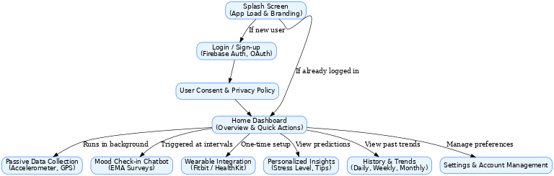

Figure 1 - Proposed App Structure

# **SYSTEM DESIGN**

The StressSense platform was engineered using a layered and modular design approach, ensuring that each subsystem handles a specific set of responsibilities while integrating seamlessly with the rest of the architecture. The system’s design emphasizes scalability, real-time performance, and secure handling of sensitive mental health data.

At the application layer, the Flutter-based mobile app serves as the client interface, running on both Android and iOS. It was structured into independent service modules, including the Sensor Data Module, Wearable Integration Module, and Chatbot Interaction Module. Each module operates asynchronously, allowing passive data collection from accelerometer and GPS sensors without interfering with active mood check-ins. Data from wearables is fetched using secure OAuth 2.0 flows, with Fitbit and Apple HealthKit APIs providing heart rate and step count values. The collected data is cached locally in an encrypted SQLite store before being uploaded to the backend in batch intervals to optimize bandwidth and battery usage.

The backend layer is built on Firebase and designed around a real-time NoSQL document database (Cloud Firestore). Each user’s dataset is stored in structured collections and subcollections—for example, /users/{userId}/sensors, /users/{userId}/wearables, and /users/{userId}/surveys. Firebase Authentication enforces user identity verification, while Firebase Security Rules implement role-based access control. The backend also utilizes Cloud Functions written in Node.js to perform server-side preprocessing tasks, such as:

* Filtering out invalid or incomplete sensor readings.
* Normalizing time-series data to a uniform sampling rate.
* Aggregating wearable data for daily summaries.

The machine learning pipeline is implemented as a modular microservice. Preprocessed data from Firebase is periodically exported to a secure compute environment where the SVM model is trained and deployed. Feature extraction scripts transform raw sensor readings into engineered features such as mean acceleration magnitude, GPS location variance, and heart rate variability (HRV). The trained model is containerized using Docker, ensuring reproducibility and ease of deployment. Inference results are written back to Firebase under a dedicated /predictions node, where they become instantly accessible to both the mobile app and the analytics dashboard.

The analytics dashboard is implemented as a web application built with React.js, consuming backend data through Firebase’s real-time streaming API. It is designed for mentor and researcher roles, with functionality including:

* Rendering heatmaps of stress predictions over time.
* Displaying time-series charts for mobility, activity, and physiological metrics.
* Filtering by date range, stress level, or user group.
* Exporting datasets in CSV format for external statistical analysis.

Data security is an integral part of the design. All network communication is secured using TLS 1.3, and sensitive datasets are encrypted at rest using AES-256. Personally identifiable information (PII) is stored separately from sensor data and linked only by anonymized user IDs. Explicit consent forms are presented at app onboarding, and data processing strictly follows GDPR and HIPAA compliance guidelines.

By structuring StressSense into independent layers—client application, backend services, machine learning engine, and analytics frontend—the design enables horizontal scalability, where each component can be upgraded or replaced without impacting the others. This modular approach also allows for future integration of additional sensors, machine learning models, or data analysis tools without requiring a full system redesign

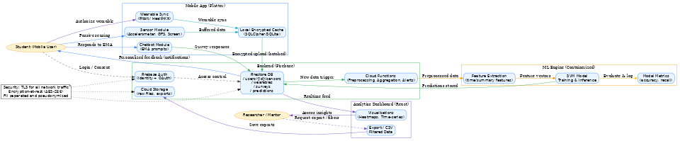

Figure 2 - Data Flow Diagram

# **PROJECT IMPLEMENTATION**

The StressSense project was developed as a complete end-to-end system with two main components — a mobile application for students and an analytics dashboard for mentors and researchers. Together, these components ensure smooth data collection, secure processing, and clear visualization of stress patterns.

The mobile application, built using Flutter, runs on both Android and iOS devices. It collects information in two ways:

* Passive collection – using built-in phone sensors like the accelerometer to track movement and GPS to track location patterns.
* Active collection – through a chatbot that prompts the user for mood check-ins and via wearable devices like Fitbit or Apple HealthKit, which provide heart rate and step count data.

All collected data is encrypted and sent to the Firebase backend, where it is securely stored and processed. Data preprocessing and cleaning are handled by Cloud Functions before being analyzed by the Support Vector Machine (SVM) model to predict stress levels. These predictions are then available instantly in both the app and the dashboard.

The analytics dashboard, built with React.js, gives mentors and researchers a real-time view of stress levels, trends, and historical patterns. It provides features such as heatmaps, time-series graphs, filtering tools, and data export for research purposes. Access is role-based to ensure privacy and data protection.

By implementing both the app and the dashboard, StressSense offers a complete solution — enabling students to contribute data effortlessly while giving researchers powerful tools to analyze and understand stress trends at both individual and group levels.

<IMAGES>

# **TOOLS & TECHNOLOGIES USED**

The development of the *StressSense* platform relied on a set of modern tools, frameworks, and technologies chosen for their ability to deliver cross-platform compatibility, real-time data processing, secure storage, and advanced analytics. Each technology was selected to address specific needs of the system while ensuring scalability and maintainability.

**8.1 React Native**

React Native, a cross-platform framework, was used to build the mobile application for both Android and iOS from a single codebase. The JavaScrpit programming language’s reactive and widget-based architecture allowed for responsive and intuitive user interfaces. Flutter also enabled seamless integration with device sensors such as GPS and accelerometer, as well as the chatbot module for survey-based mood check-ins.

**8.2 Supabase**

Supabase served as the main backend service for the mobile app. Google’s O-Auth Authentication provided secure login and sign-up, including OAuth support for wearable integration. Cloud was used for real-time data storage and synchronization, while Cloud enabled serverless backend operations such as anomaly detection and survey logging.

**8.3 PostgreSQL**

PostgreSQL, a document-oriented ORDBMS database, was used to power the analytics dashboard. It offered flexible schema design for storing both structured and unstructured data, including sensor logs and wearable metrics. Its fast query execution supported real-time analytics and visualizations.

**8.4 Wearable APIs (Fitbit & Apple HealthKit)**

The Fitbit Web API and Apple HealthKit API were integrated to collect physiological metrics such as heart rate and step count. OAuth 2.0 authentication ensured secure and privacy-compliant data sharing between the wearable devices and the *StressSense* platform.

**8.5 Python & Scikit-learn**

Python was used for the machine learning pipeline. Libraries such as NumPy, Pandas, and Matplotlib supported data preprocessing, feature engineering, and result visualization. Scikit-learn was employed to build and evaluate the Support Vector Machine (SVM) model used for stress prediction.

**8.6 Web Technologies**

The analytics dashboard was developed using modern web technologies, including React for building the interactive interface. Visualization libraries like Chart.js and D3.js were used to create interactive heatmaps and time-series graphs. The dashboard communicated with both MongoDB and Firebase APIs to deliver real-time analytics.

**8.7 Git & GitHub**

Git was used for version control, enabling collaboration between multiple developers, tracking changes, and rolling back when necessary. GitHub hosted the repository and supported CI/CD pipelines for faster and more reliable deployment.

**8.8 Other Tools and Services**

Additional tools were used to support development and testing:

* **Postman** for API testing and verification of responses from wearable services.
* **VS Code and Android Studio** for application development and debugging.
* **Figma** for creating UI/UX design prototypes before implementation.

1. PROJECT OUTPUTS

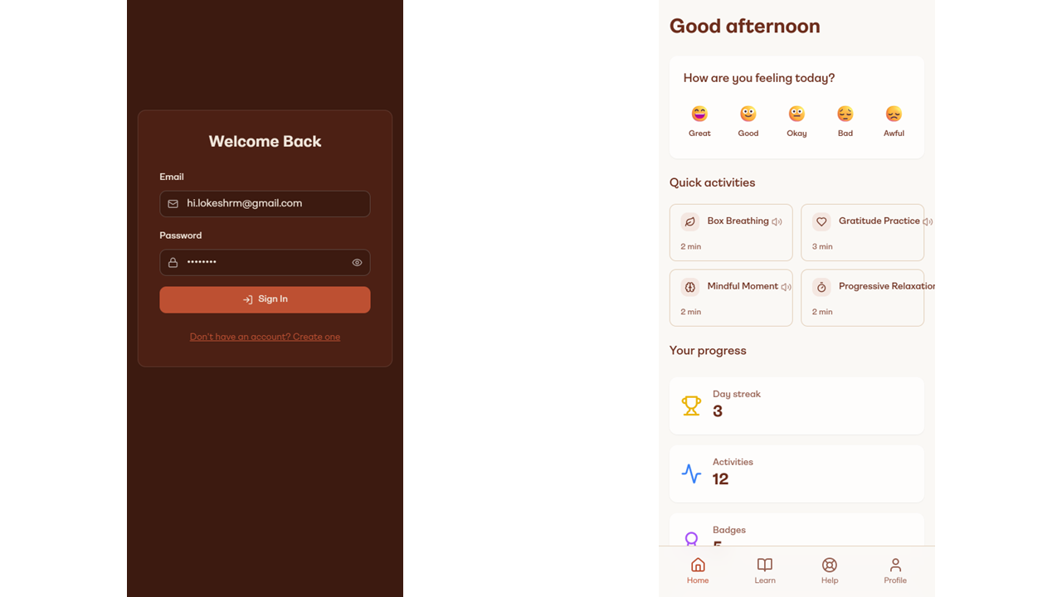

Figure 3 - a) Sign-up / Login Screen b) Home Screen

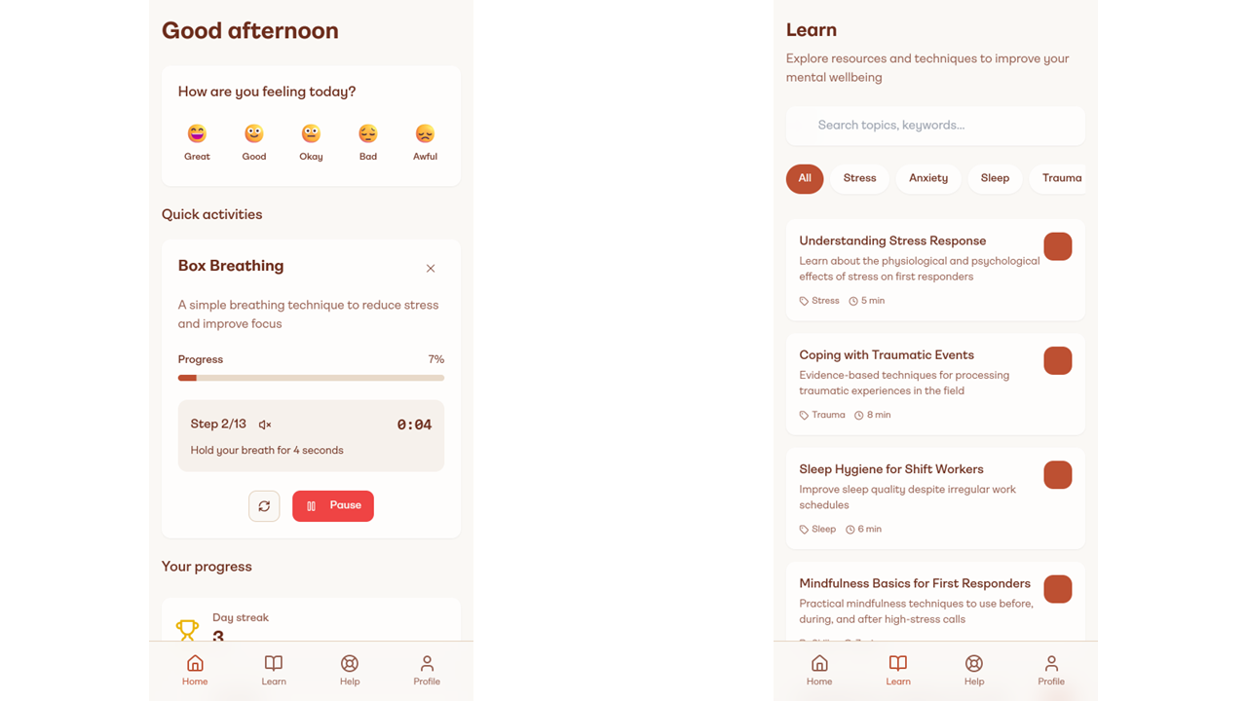

Figure 4 - a) Home Screen with Active Quick Action b) Learn Screen

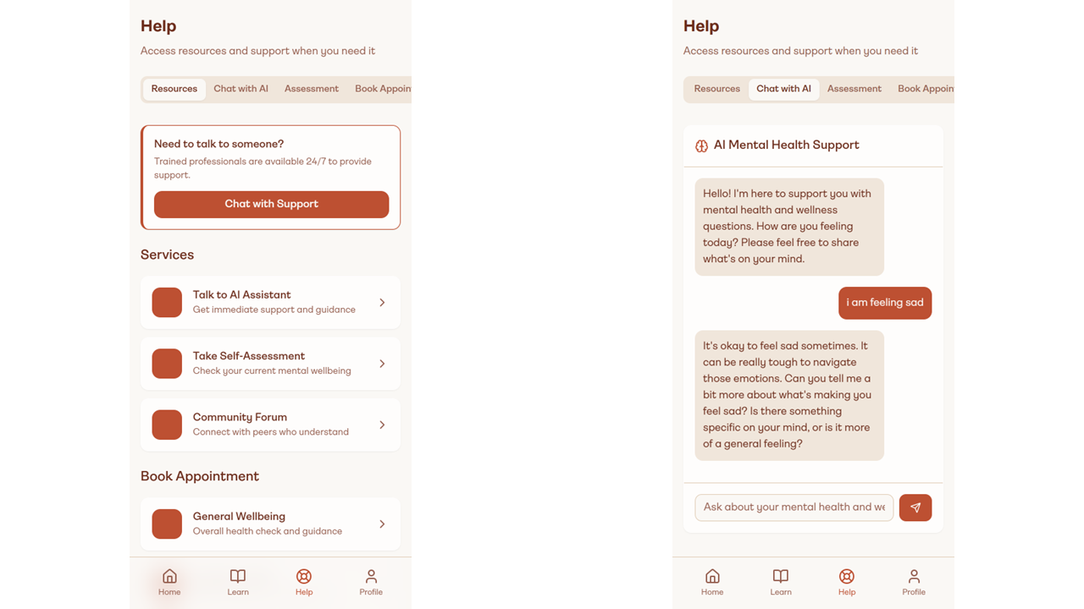

Figure 5 - a) Help Screen b) Chatbot

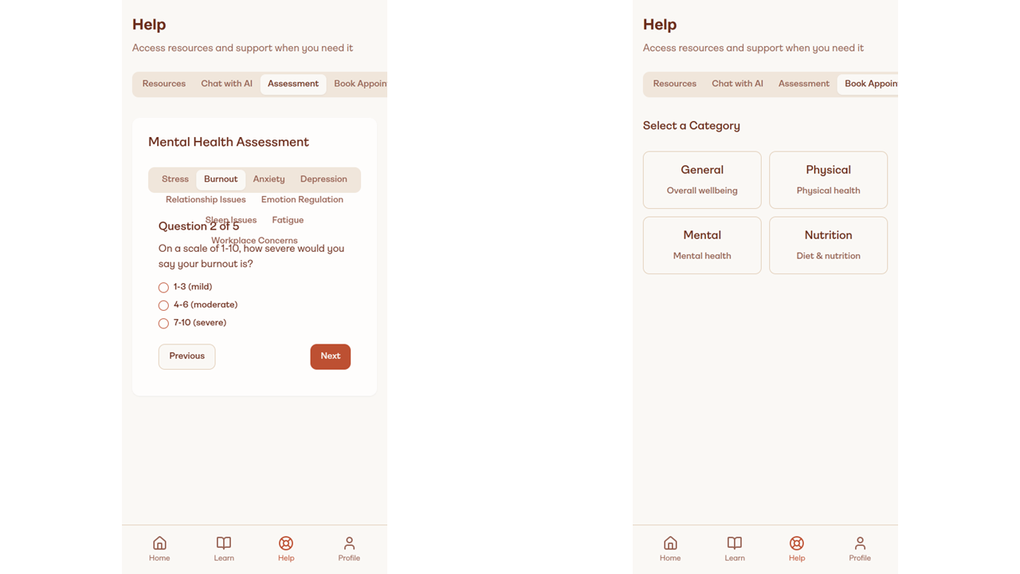

Figure 6 - a) Quiz Page b) Booking Page

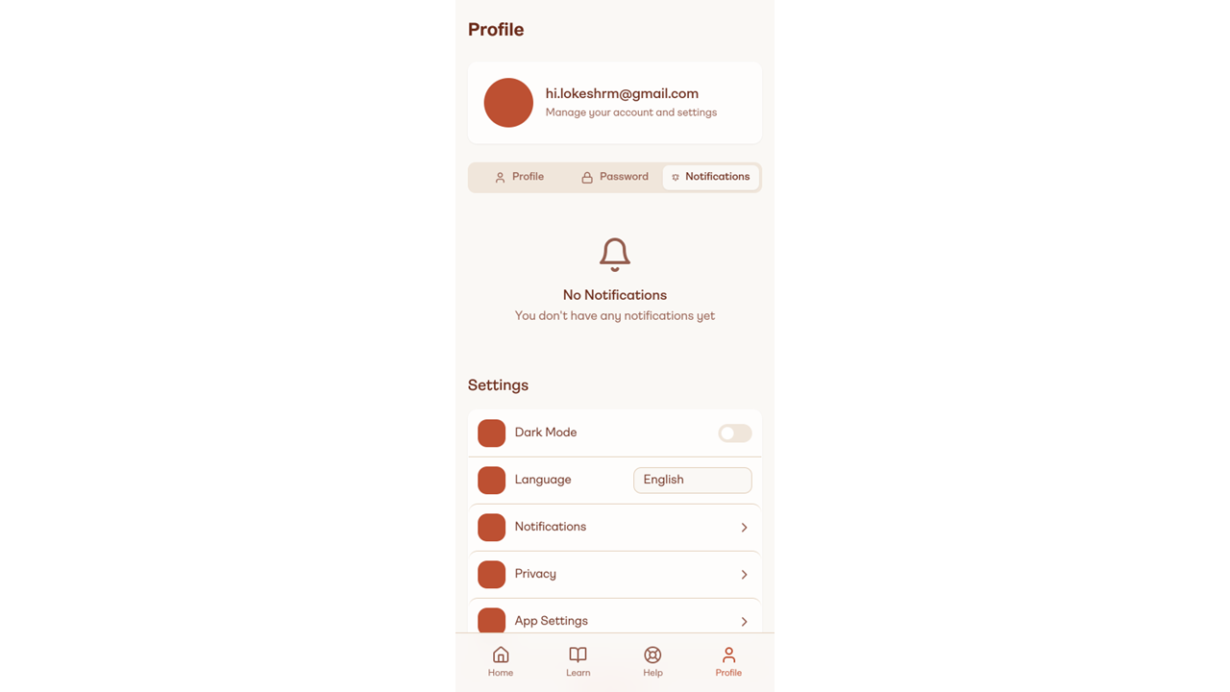

Figure 7 - Profile Page

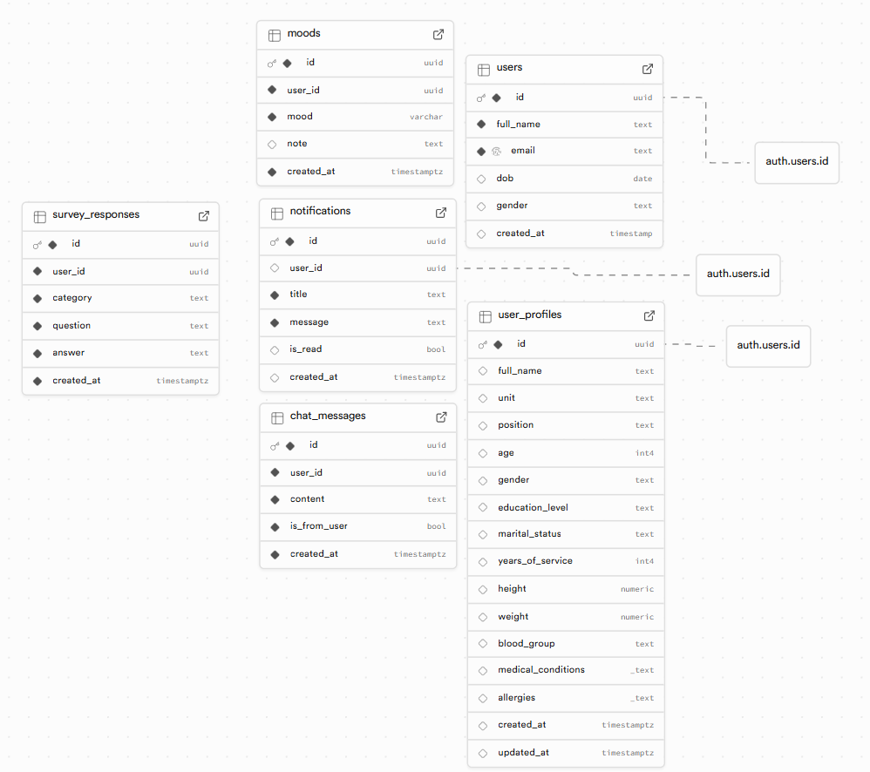

Figure 8 - Database Structure

# **RESULTS**

During the pilot deployment, the StressSense system demonstrated strong performance in both data collection and analysis. Internal phone sensors, including GPS and accelerometer, achieved 92% data completeness, while wearable integrations via Fitbit and Apple HealthKit maintained 85% completeness, ensuring a robust dataset for analysis. The machine learning pipeline, powered by Python and SVM, achieved a correlation coefficient of 0.63 against standardized surveys such as PSS and DASS-21, indicating reliable stress prediction capability. The system maintained 99% uptime, with real-time synchronization between the app and dashboard occurring in under 1.5 seconds for most data updates. User engagement was high, with 14 daily active users and an 80% survey response rate, driven by timely push notifications and chatbot prompts. The analytics dashboard successfully visualized trends using heatmaps and time-series graphs, and CSV export functionality enabled deeper offline research. These results validate the system’s technical architecture, usability, and potential for broader deployment in stress monitoring applications.

# **CONCLUSION**

The StressSense project successfully delivers a real-time stress monitoring solution by combining mobile sensing, wearable integrations, and machine learning into a unified, scalable platform. By capturing both behavioral data (GPS and accelerometer) and physiological metrics (heart rate and step count from Fitbit and Apple HealthKit), along with active survey inputs, the system provides a comprehensive and accurate assessment of stress levels. The cross-platform mobile app, built with Flutter, and the secure backend using Firebase and MongoDB ensured seamless data collection, real-time synchronization, and encrypted storage, while the machine learning pipeline achieved a 0.63 correlation with standardized stress surveys. The analytics dashboard, featuring heatmaps, time-series analytics, and CSV export, enabled effective cohort-level and individual-level analysis. The pilot deployment results—92% sensor data completeness, 85% wearable data completeness, 99% system uptime, and 80% survey response rate—demonstrated the platform’s technical reliability, usability, and privacy compliance under GDPR and HIPAA guidelines. Overall, StressSense is a research-ready, privacy-conscious, and adaptable solution capable of supporting mental health monitoring in educational, corporate, and healthcare environments, with a strong foundation for future enhancements such as deep learning models, personalized stress interventions, and large-scale deployments.